# **Connect to Linux Servers**

1. <https://login.it.ilstu.edu/> Select “Terminal Server”. This will open another browser for authentication. Login using ULID and password.
2. After successful login, you should see all the three Linux Terminal Servers – Ash, Aspen, and Bur. Select the one with MONITOR ICON. Select the one with least number of users.

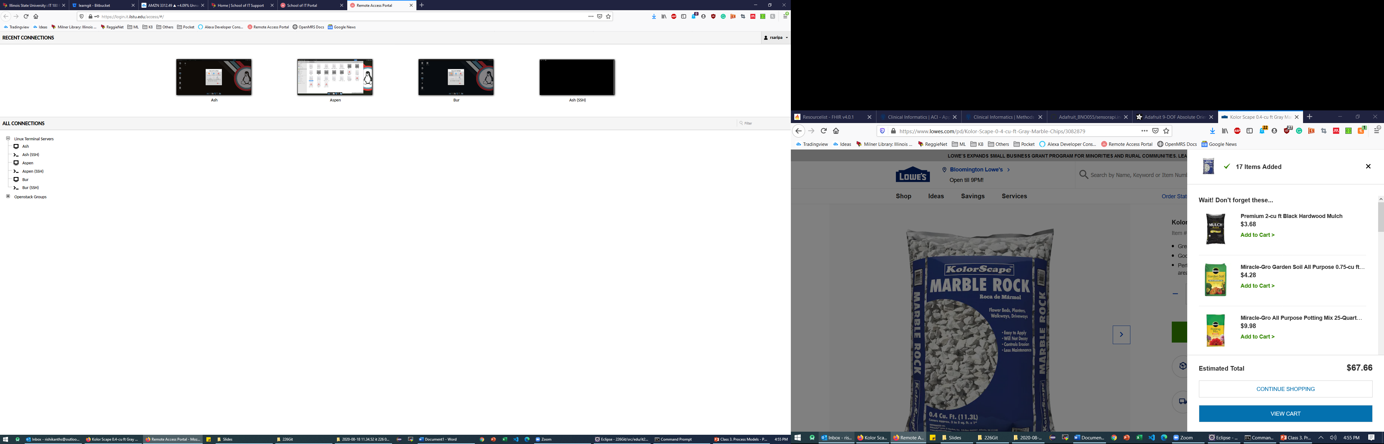

1. You should have you Linux Terminal open.
2. Start ATOM editor. You can do it two way:
   1. In the top-left, click “Application”, select “Development” and you will see Atom
   2. Open the command prompt and type “atom”. You can open the command prompt by click on the icon (with $) on the bottom of Linux desktop (Red outline below).

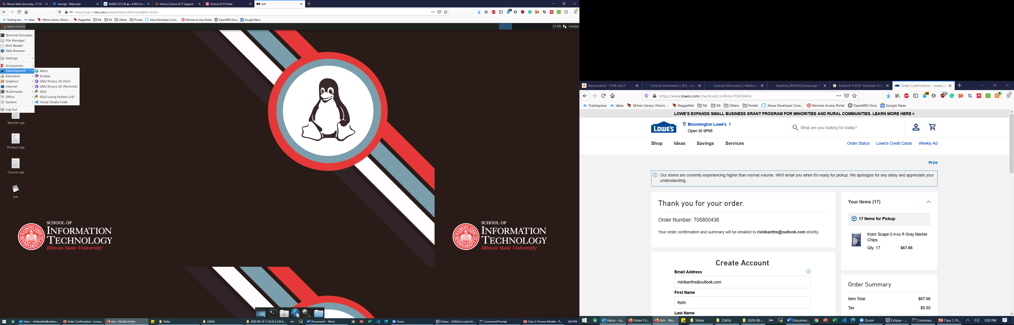

1. In Atom, under the “File” menu “New File” or CTRL + N. This will create an “untitled” file.
2. Save the file at the desired location with any file name but with “.cpp” as its extension to save the file as a C++ file. For example “Test.cpp” or “Main.cpp”